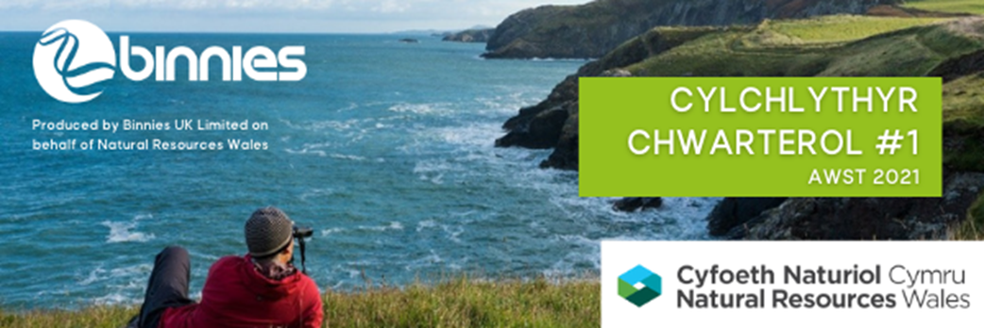

|  |  |
| --- | --- |
|  | |
| Cyflwyniad i’r prosiect |  |
| Yn ddiweddar mae Cyfoeth Naturiol Cymru a Llywodraeth Cymru, mewn cydweithrediad â Chyngor Gwynedd, wedi lansio prosiect 'Ein Llwybrau Byw' / ‘Our Living Trails’ sydd â'r nod hirdymor o hyrwyddo ac adfer bioamrywiaeth ar hyd coridor Llwybr Arfordir Cymru. Mae Binnies wedi cael eu contractio gan CNC i gynnal y prosiect 9 mis hwn sydd hefyd yn ceisio hyrwyddo mwy o gysylltiad rhwng pobl a natur, fel bod mwy o bobl yn deall pwysigrwydd amgylchedd naturiol iach, a'r manteision y mae'n eu cynnig i ni.  Mae tir ar hyd coridor Llwybr Arfordir Cymru, sy’n 870 milltir o hyd, yn cynnwys tir fferm, cefn gwlad agored, clogwyni, dolydd, traethau ac amgylcheddau trefol. Mae'r tir yn rhoi cyfle pwysig i fynd i'r afael â heriau colli bioamrywiaeth, newid hinsawdd a 'gwasgfa' arfordirol, gan hyrwyddo cymdeithas iach a gwydn yr un pryd. Bydd y prosiect yn gweithio mewn partneriaeth â thirfeddianwyr, gan y byddant yn rhan hanfodol o’r prosiect. Bydd yn ymchwilio i 'arferion gorau' ac yn argymell dull o fynd i’r afael o ddifrif â’r broses o gyflwyno prosiectau gwella bioamrywiaeth ar hyd coridor Llwybr Arfordir Cymru, a llwybrau a hawliau tramwy cenedlaethol eraill yng Nghymru o bosib, yn y blynyddoedd i ddod.   |  |  | | --- | --- | |  |  | | |
| Nodau ac amcanion Llwybrau Byw | |
| Dysgu sydd wrth wraidd y prosiect Llwybrau Byw. Rydyn ni eisiau gwybod, beth yw'r ffordd orau o wella bioamrywiaeth ar hyd Llwybr Arfordir Cymru? Rydyn ni am wneud hyn mewn ffordd sy'n sicrhau cynifer o fanteision eraill â phosib fel iechyd, ansawdd dŵr, dal a storio carbon, rheoli perygl llifogydd. Felly, mae angen i ni feddwl am y pethau canlynol:   |  |  | | --- | --- | | * Pa fathau o brosiectau gwella bioamrywiaeth ddylen ni eu cynnal, ble a pham? * Pa ddata sydd ei angen arnon ni a gyda phwy y mae angen i ni weithio? * Beth yw'r ffordd orau o weithio gyda thirfeddianwyr a rhanddeiliaid eraill ar hyd Llwybr Arfordir Cymru? * Sut mae ariannu'r prosiectau hyn a mesur eu heffaith? * Beth yw'r ffordd orau o godi ymwybyddiaeth y cyhoedd o fioamrywiaeth a'r manteision a ddaw yn ei sgil? * Beth yw'r ffordd orau o ddiffinio coridor Llwybr Arfordir Cymru? |  |   Bydd y prosiect yn ymchwilio i'r hyn sydd wedi gweithio'n dda yn y gorffennol drwy ddysgu o 'arferion gorau'. Rydyn ni hefyd am ddysgu o'r hyn nad yw wedi gweithio cystal! Fel rhan o'r prosiect, byddwn yn dewis dwy astudiaeth achos, o restr hir o astudiaethau achos a enwebwyd gan fynychwyr ein Gweminar Ragarweiniol (a gynhaliwyd ar 15 Gorffennaf 2021 – gallwch ei gwylio [yma](https://gbr01.safelinks.protection.outlook.com/?url=https%3A%2F%2Fwww.youtube.com%2Fwatch%3Fv%3DtcJHd_GwHh0&data=04%7C01%7CMooreF%40binnies.com%7Ce8549c2c20e0486e74a608d966222ffb%7Cc4ac543552dc40599473e00d7ff2e786%7C0%7C0%7C637653119305448738%7CUnknown%7CTWFpbGZsb3d8eyJWIjoiMC4wLjAwMDAiLCJQIjoiV2luMzIiLCJBTiI6Ik1haWwiLCJXVCI6Mn0%3D%7C1000&sdata=89%2BhKm88fDu7jD9nthtXtNcBr6iVnNk0hBILT3SbgBI%3D&reserved=0)). | |
| Astudiaethau peilot |  |
| Byddwn hefyd yn dechrau dau brosiect peilot 'gwella bioamrywiaeth' yn 2021 yng Ngwynedd, gan ganolbwyntio ar ddysgu o'r broses o'u rhoi ar waith.  Bydd y prosiect peilot cyntaf yn gweithio gyda fferm i adfer gwrychoedd a chloddiau, sy’n gynefin pwysig. Bydd y prosiect yn ystyried rheolaeth ar bori ac adfer cynefinoedd arfordirol. Bydd yr ail brosiect peilot yn mabwysiadu dull fferm gyfan, a bydd yn cynnwys adfer cynefinoedd, arferion ffermio a rheoli pwysau datblygu. Mae trafodaethau'n mynd rhagddynt ar hyn o bryd a bydd cynlluniau manylach, gan gynnwys lleoliad y prosiectau, yn cael eu rhyddhau cyn gynted ag y cawn gytundeb gan y tirfeddianwyr a'r ffermwyr. | |
| Eich syniadau chi |  |
| Rydyn ni’n awyddus i glywed gennych chi. Oes gennych chi syniadau ar sut i gynyddu bioamrywiaeth ar hyd Llwybr Arfordir Cymru? A oes yna astudiaethau achos y gallwn ni ddysgu ganddynt a gwella arnynt? Efallai eich bod wedi clywed am brosiectau tebyg yn y DU neu’n bellach i ffwrdd y gallen ni ddysgu ganddynt? Os hoffech chi enwebu astudiaeth achos, neu ymuno â'n rhestr bostio, cysylltwch â Quentin Grimley yn Cyfoeth Naturiol Cymru: [Quentin.Grimley@cyfoethnaturiolcymru.gov.uk](mailto:Quentin.Grimley@cyfoethnaturiolcymru.gov.uk). | |

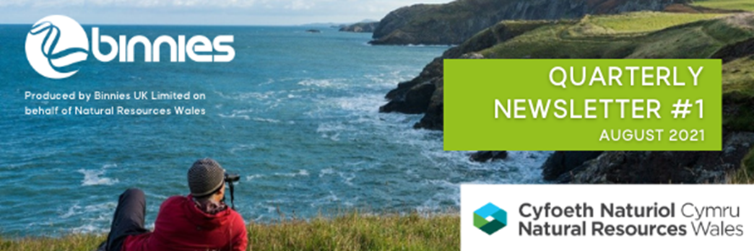

|  |  |
| --- | --- |
|  | |
| Project introduction |  |
| Natural Resources Wales and the Welsh Government, in collaboration with Gwynedd Council, have recently launched the ‘Ein Llwybrau Byw’ / Our Living Trails project which has the long-term aim to promote and restore biodiversity along the Wales Coast Path corridor. Binnies has been contracted by NRW to deliver this 9-month long project which also aims to promote greater connection between people and nature, so that more people understand the importance of a healthy natural environment, and the benefits it brings to us.  Land along the 870-mile Wales Coast Path corridor includes farmland, open countryside, cliffs, meadows, beaches and urban environments. The land provides an important opportunity to address the challenges of biodiversity loss, climate change and coastal ‘squeeze’ whilst promoting a healthy, resilient society. The project will be working in partnership with landowners, as they will be an integral part of the project. It will investigate ‘best practice’ and recommend an approach to ‘scale up’ the roll out of biodiversity improvement projects along the Wales Coast Path corridor, and potentially other national trails and rights of way in Wales in coming years.   |  |  | | --- | --- | |  |  | | |
| Our Living Trails’ aims and objectives | |
| The Our Living Trails project is about learning. We want to identify how do we best go about improving biodiversity along the Wales Coast Path. We want to do this in a way which optimises as many other benefits as we can such as health, water quality, carbon sequestration, flood risk management. As such we need to think about:   |  |  | | --- | --- | | * What types of biodiversity improvement projects do we do, where and why? * What data do we need and who do we need to work with? * What’s the best way to work with landowners and other stakeholders along the Wales Coast Path? * How do we fund these projects and measure their impact? * How do we best raise public awareness of biodiversity and the benefits it brings? * What’s the best way to define the Wales Coast Path corridor? |  |   The project will be investigating what has worked well in the past by learning from ‘best practice’. We also want to learn from what has not worked so well! As part of the project, we will be selecting two case studies, from a long-list of case studies nominated by attendees to our Introductory Webinar (held on the 15th July 2021 – you can watch it [here](https://gbr01.safelinks.protection.outlook.com/?url=https%3A%2F%2Fwww.youtube.com%2Fwatch%3Fv%3DtcJHd_GwHh0&data=04%7C01%7CMooreF%40binnies.com%7Ce8549c2c20e0486e74a608d966222ffb%7Cc4ac543552dc40599473e00d7ff2e786%7C0%7C0%7C637653119305448738%7CUnknown%7CTWFpbGZsb3d8eyJWIjoiMC4wLjAwMDAiLCJQIjoiV2luMzIiLCJBTiI6Ik1haWwiLCJXVCI6Mn0%3D%7C1000&sdata=89%2BhKm88fDu7jD9nthtXtNcBr6iVnNk0hBILT3SbgBI%3D&reserved=0)). | |
| Pilot studies |  |
| We will also be starting two pilot ‘biodiversity improvement’ projects in 2021 in Gwynedd, with a focus on learning from the process of getting them up and running.  The first pilot project will work with a farm to restore hedgerows and the important ‘cloddiau’ habitat. The project will consider grazing management and coastal habitat restoration. The second pilot project will take a whole farm approach, and will include habitat restoration, farming practices and management of development pressures. Discussions are on-going and more detailed plans, including the location of the projects, will be released as soon as we have agreement from the landowners and farmers. | |
| Your ideas |  |
| We would like to hear from you. Have you got ideas on how to increase biodiversity along the Wales Coast Path? Are there case studies we can learn from and improve upon? Maybe you’ve heard of similar projects in the UK or beyond that we could learn from? If you would like to nominate a case study, or to join our mailing list, please get in touch with Quentin Grimley at Natural Resources Wales: [Quentin.Grimley@cyfoethnaturiolcymru.gov.uk](mailto:Quentin.Grimley@cyfoethnaturiolcymru.gov.uk). | |